Effect of Tree Canopy on Presence of *P. tomentosa*

Sarah Pratt, College of William and Mary

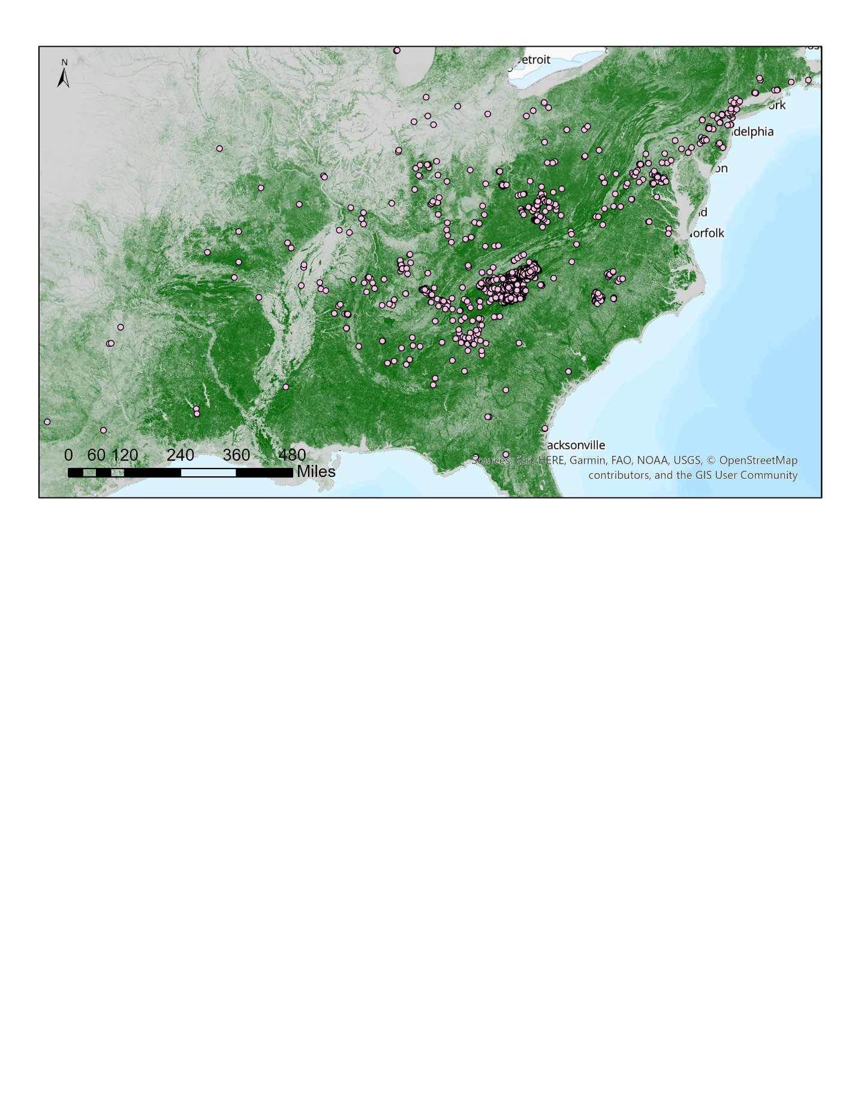

Figure 1: Raw data, base layer is raster of Tree Canopy Cover with citizen science point data of Princess tree superimposed

**Abstract**

Recent studies show an invasive tree species *Paulownia tomentosa* or Princess tree establishing well in areas of disturbance due to numerous factors. One of the most important of these factors is tree canopy cover. Because of this, burned areas show greater proliferation of this invasive since canopy cover is decreased after instances of fire (Kuppinger 2008). To test these hypotheses this study looks at the association of tree canopy cover with *P. tomentosa*. Data used includes a raster layer of tree canopy cover for the entire U.S. and citizen science points of recorded Princess tree. Analysis involved creating a KDE and UD to map probability of the species in the study area and correlate it with TCC values. Although the statistical analyses show an opposite trend, when exploring map data, a clear spatial pattern appears. The *P. tomentosa* points, for a smaller extent than the U.S., indicate clumping around areas of less dense canopy cover. This relationship should be further investigated to support the spatial pattern with statistical analysis.

**Introduction**

*Pawlonia tomentosa* is a tree species historically endemic to Eastern and Central China. It was introduced to North America for use as a crop tree or an ornamental plant, and from there it escaped cultivation and began to propagate all along the Eastern side of the United States into Canada (Nix 2019). Since its introduction it has been classified as an invasive in the United States and globally it has been found on every continent except Antarctica (Franz 2007). *P. tomentosa* is a medium sized tree that usually reaches heights of 50-60ft on average (Nix 2019). In comparison to other invasive plants this tree has not been shown to propagate as quickly but despite this, this species is significant because of the areas it is more likely to invade. Studies have shown two factors to be very important for the proliferation of *P. tomentosa*. These two factors are tree canopy cover and exposed soil. Princess tree is very intolerant to shade and therefore, if tree canopy cover is very dense in certain areas, *P. tomentosa* will have a more difficult time spreading (Innes 2009). The other factor that seems to be influential for Princess tree is exposed soil. This is due to the preferred environment for seed germination. *P. tomentosa* is more likely to thrive in areas with exposed ground and less organic matter such as leaf litter (Innes 2009). These two factors that allow for the furthering of this invasive species can be concerning in relation to fires, either wildfires or prescribed fires. Fire generally will establish the preferred conditions for *P. tomentosa* that allow the species to spread, by decreasing tree canopy cover, and exposing the ground (Kuppinger 2008). In general, wildfires have been showing a significant trend, with the last two decades displaying a substantial increase in total burned area. And this trend is likely to continue with rising temperatures from global warming. In areas where prescribed fires are implemented to increase biodiversity, certain studies have found that Princess tree has taken advantage of these conditions and displaced native species (Kuppinger 2008). With this pattern in mind *P. tomentosa* should be monitored closely to measure the level at which it is spreading in disturbed areas in the United States.

**Methods**

The datasets used for this study were found for the extent of the entire United States. The first dataset is a raster layer displaying Tree Canopy Cover (TCC), and the second dataset is point data of reported sightings of *P. tomentosa* as collected by multiple citizen science forums and gathered into one dataset (Figure 1). After bringing in both layers, they were checked to be in the same Geographic Coordinate System, which was chosen to be NAD 1983. After this, the TCC raster was reclassified into 5 levels of canopy cover. The lower values being less dense canopy and higher levels being denser canopy. This step was performed to streamline the raster for accessibility in statistical analyses. After reclassifying the raster layer, this simplified TCC data was extracted to the specific citizen science *P. tomentosa* points, therefore showing the level of tree canopy cover at each of the reported sites of Princess tree. Before creating a Kernel Density Estimation (KDE) the points were switched to a projected coordinate system, NAD Albers 1983. Then, from these projected points a Kernel Density Estimation (KDE) was created to map where these points were densest. By summing up the cells and dividing all cells by the sum the KDE was turned into a Utilization Distribution (UD). This UD is an analysis that maps the probability of *P. tomentosa* being found throughout the study area. To plot the correlation between the probability of Princess tree presence and canopy cover data, random points were created and values of the UD and TCC were extracted to these points.

After completing the following steps in ArcGIS Pro, attribute tables were exported to analyze the data in excel. In excel, UD values were summed up by canopy cover level to show the probability of Princess tree occurring in each canopy cover level. Another dataset with the number of sites plotted against tree canopy cover level was summed to get the total count of *P. tomentosa* sites in each of the canopy levels (Table 2 and Figure 2). These statistical analyses were represented in a few figures and compared to maps exported from ArcGIS Pro to observe the relationship of Princess tree presence and tree canopy cover in the data.

**Results**

To effectively detect the effect of tree canopy data on the occurrence of *P. tomentosa* two analyses were performed. Both used excel functions to sum up data based on canopy level. The first analysis used the number of reported sightings of Princess tree and compared it to the canopy level. After summing these points up a bar graph was created to illustrate the relationship of abundance of Princess tree by canopy level (Figure 2). Unfortunately, the trend shown depicts a higher abundance of Princess tree in areas of denser canopy. Another analysis was performed using UD values plotted against canopy level to compare probability of Princess tree versus abundance. The random points with UD values and TCC level data were plotted on a scatterplot but the data was found to be inconclusive in a graph of this kind. To mitigate this issue, the UD probabilities were summed up by canopy level. The finding of this analysis showed a similar trend to Figure 2. The pie chart shows canopy levels 4 and 5 occupying over 75% of the chart showing that according to the data *P. tomentosa* was more likely to be found in areas of denser canopy.

Despite the statistical analyses showing a trend of *P. tomentosa* being correlated with denser canopy, maps show a spatial pattern that is hidden to the analyses performed. To evaluate the difference in statistical analysis and spatial trends a map of the KDE was superimposed with *P. tomentosa* points with TCC data. The lighter colored points depict less canopy while the darker points show denser canopy (Figure 4). Another map used to identify the spatial trend in the data showed the Princess tree points superimposed onto the TCC raster layer (Figure 5).

**Discussion**

The results of this study while being contradictive can be explained by investigating the figures as well as noting potential sources of bias. Based on the statistical analyses implemented a general trend was seen correlating denser canopy with Princess tree. Both the count data in a bar graph and pie chart made from the UD depicted this relationship (Figures 2 and 3). But, by comparing this with spatial datasets a pattern is shown that warrants further observation. By taking a closer look at the KDE a potential explanation for this disconnect can be found. The KDE if used for a UD will have large area with a higher probability of species presence, but within this area the TCC data points seem to be highly variable (Figure 4). When equated with the same points on the TCC raster layer a spatial trend arises between clustering of *P. tomentosa* points and areas of less dense canopy (Figure 5). Therefore, a potential bias for this study could have occurred from extracting the TCC data to the specific citizen science data points. When using citizen science data there should always be room for variation or bias in the form of standard error or confidence intervals. The other issue could be related to the difference in resolution cell size between the TCC raster layer and the citizen science points of *P. tomentosa*. In future analyses a different step might be performed to counteract these potential errors that does not involve extracting raster values to the specific points or instead creates a buffer around these points to account for error. Another potential issue could have arisen from the study area extent. The spatial trend of correlation between Princess tree and areas of less dense canopy is visible only at a smaller extent of the U.S. and thus in furthering this study the smaller extent could be applied to the statistical analyses (Figure 5). Ultimately, this study goes to show that scientists must be extra cautious when using citizen science data and must take the potential biases into account when designing the analysis of the data. But further research and analysis on the factors that allow for the propagation of the invasive species *P. tomentosa* should be performed as it could be a significant threat in disturbed areas across the United States.

**Appendix**

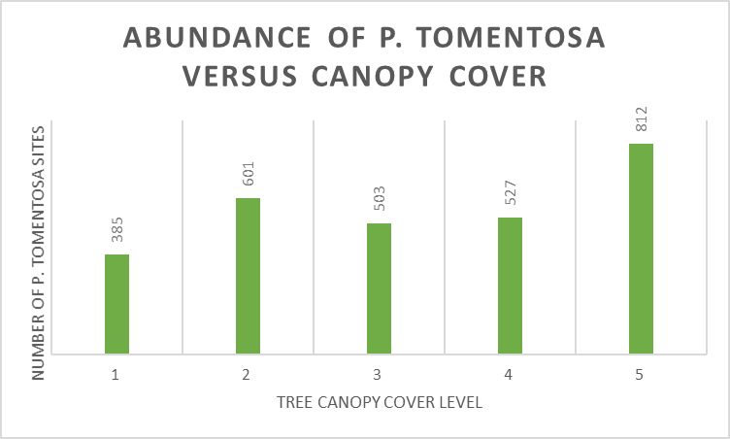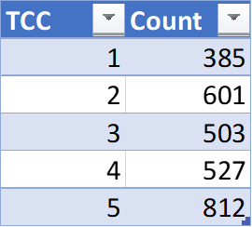

Table 2 and Figure 2: Number of *P. tomentosa* sites summed by canopy level

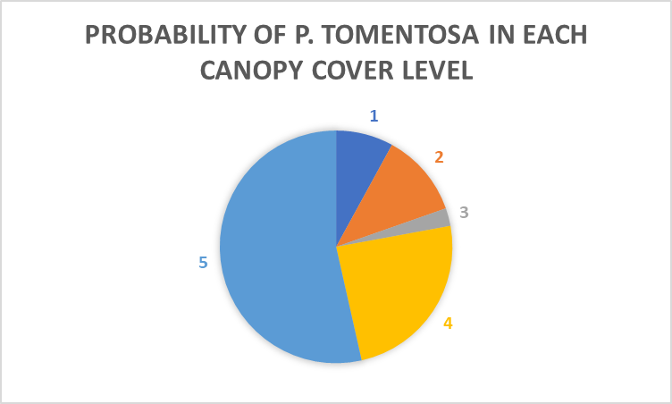

Figure 3: UD probabilities of *P. tomentosa* summed by canopy level

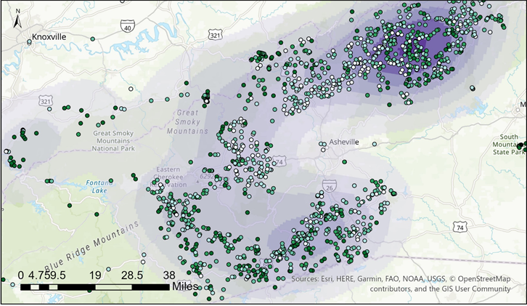

Figure 4: KDE map superimposed by Princess tree points with canopy level data shown by color

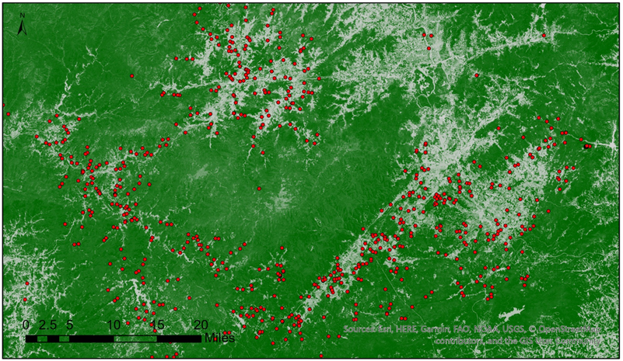

Figure 5: TCC raster superimposed with *P. tomentosa* points observed at a smaller extent

**Works Cited**

Anjozian, Lisa-Natalie. "Nature in a Name: Paulownia tomentosa—Exotic Tree, Native Problem." (2010).

EDDMapS. 2020. Early Detection & Distribution Mapping System.

The University of Georgia - Center for Invasive Species and Ecosystem Health. Available online at http://www.eddmaps.org/; last accessed November 15, 2020.

Franz, E. S. S. L. "From ornamental to detrimental? The incipient invasion of Central Europe by Paulownia tomentosa." Preslia 79 (2007): 377-389.

“FSGeodata Clearinghouse.” *USDA Forest Service FSGeodata Clearinghouse - FSGeodata Clearinghouse*, data.fs.usda.gov/geodata/.

Innes, Robin J. 2009. Paulownia tomentosa. In: Fire Effects Information System, [Online].

U.S. Department of Agriculture, Forest Service, Rocky Mountain Research Station, Fire Sciences Laboratory (Producer). Available: https://www.fs.fed.us/database/feis/plants/tree/pautom/all.html [2020, November 14].

Kuppinger, Dane Mitchell. Post-fire vegetation dynamics and the invasion of Paulownia tomentosa in the southern Appalachians. The University of North Carolina at Chapel Hill, 2008.

Nancy Loewenstein, Auburn University, Bugwood.org

Nix, Steve. “Invasive Trees in North America.” *ThoughtCo*, 15 June 2019, www.thoughtco.com/seven-common-invasive-tree-species-in-north-america-4108964

Rebekah D. Wallace, University of Georgia, Bugwood.org

USDA, NRCS. 2020. The PLANTS Database (http://plants.usda.gov, 15 November 2020). National Plant Data Team, Greensboro, NC 27401-4901 USA.